The Bartlett Quick-Start Guide

- Uncap your Bartlett 3. If a window appears with the PEHR program icon and folders
- Plug it into a free USB port on your computer Data and Help, skip to step 6.
4. Otherwise, double-click on My Computer (Arrow 2).
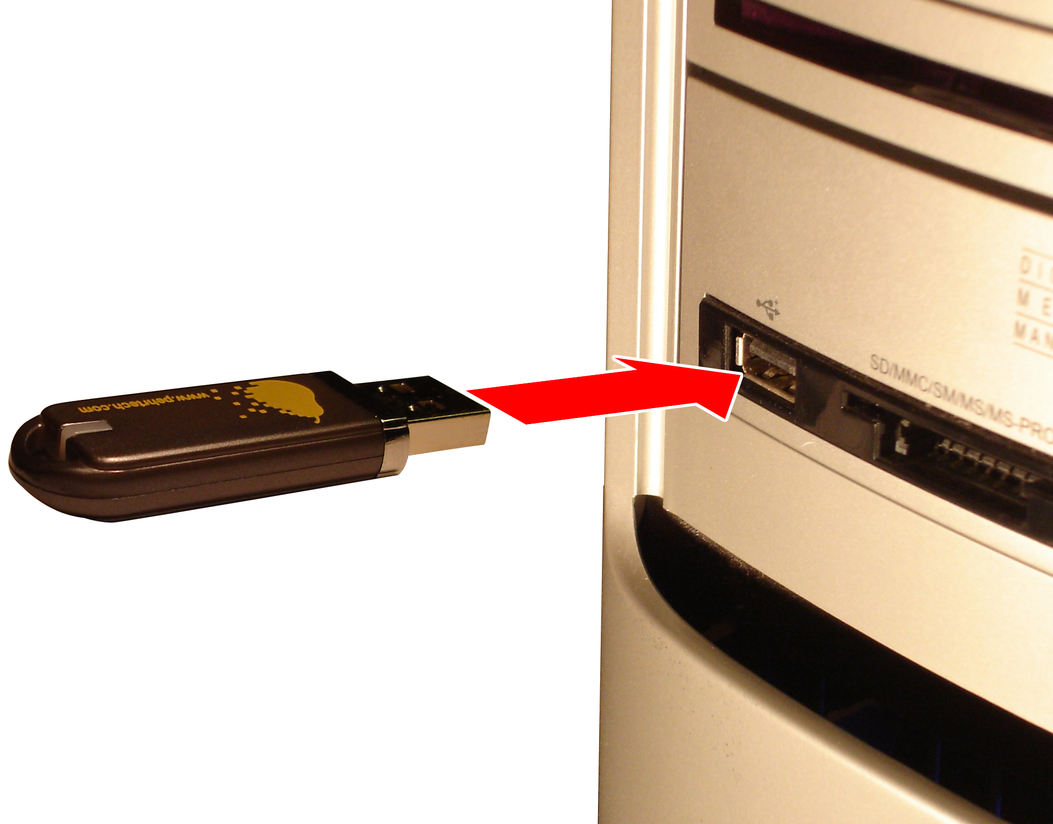
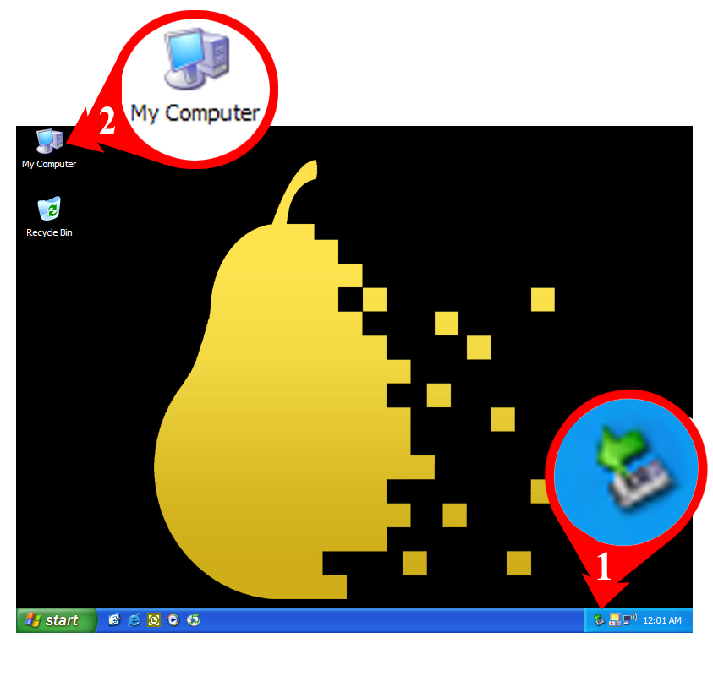
- In the window that appears, double-click on the PEHR drive icon.
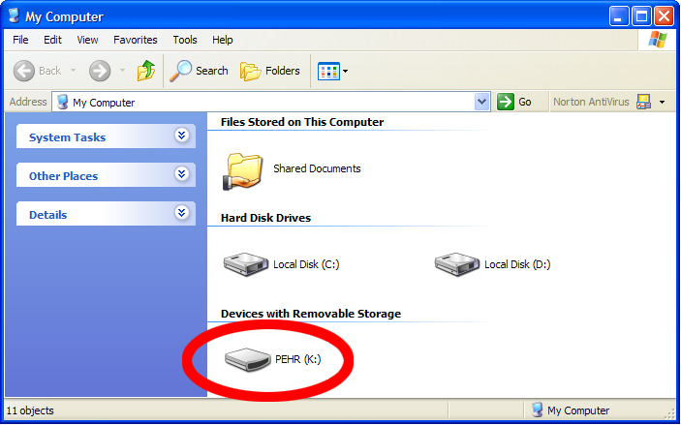
6. In this final window, double-click on the PEHR Program icon:
.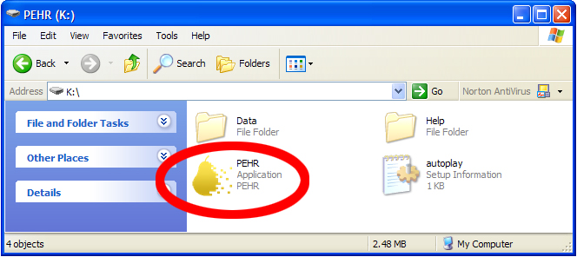 7. Click on the green arrow icon (Arrow 1) to stop the drive.

Bartlett
Quick Start Guide

